**PBO-Hadiah Teori Pertemuan 10**

**Bagian A**

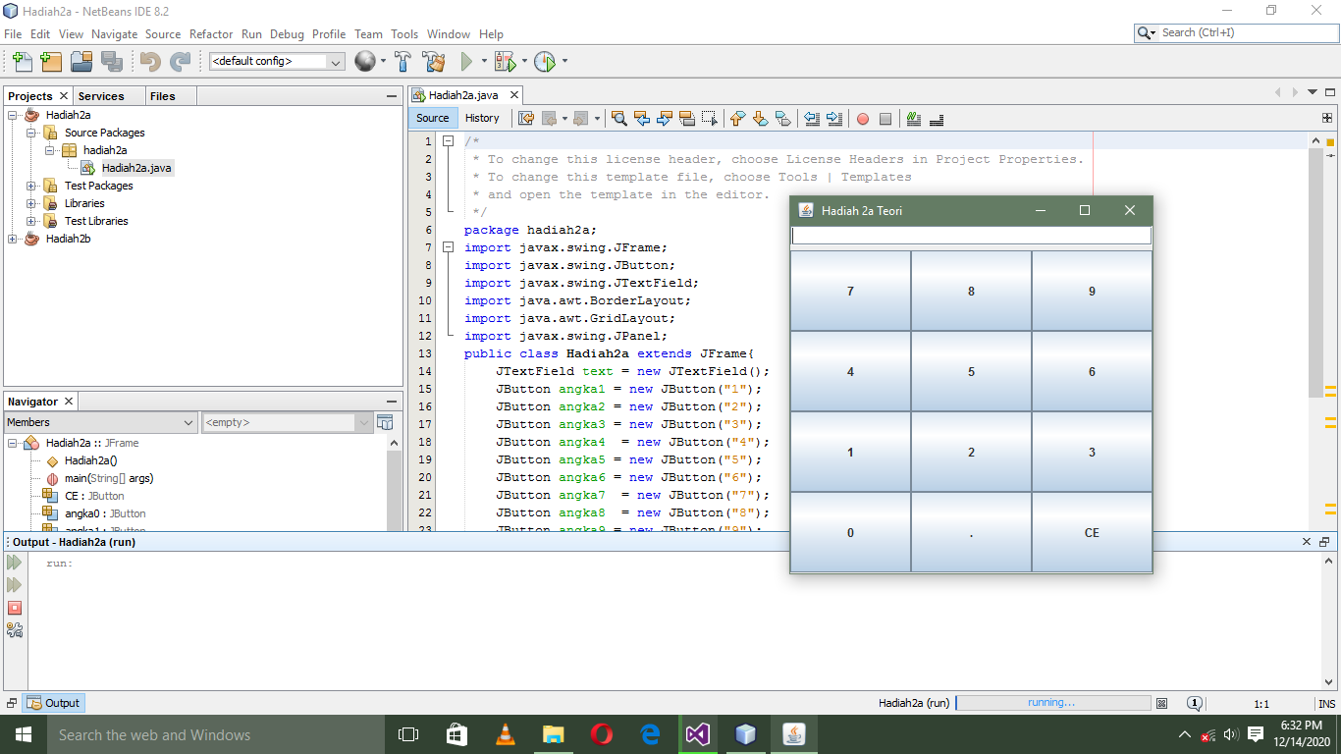

package hadiah2a;

import javax.swing.JFrame;

import javax.swing.JButton;

import javax.swing.JTextField;

import java.awt.BorderLayout;

import java.awt.GridLayout;

import javax.swing.JPanel;

public class Hadiah2a extends JFrame{

JTextField text = new JTextField();

JButton angka1 = new JButton("1");

JButton angka2 = new JButton("2");

JButton angka3 = new JButton("3");

JButton angka4 = new JButton("4");

JButton angka5 = new JButton("5");

JButton angka6 = new JButton("6");

JButton angka7 = new JButton("7");

JButton angka8 = new JButton("8");

JButton angka9 = new JButton("9");

JButton angka0 = new JButton("0");

JButton titik = new JButton(".");

JButton CE = new JButton("CE");

public Hadiah2a(){

super(" Hadiah 2a Teori");

setSize(300, 300);

setDefaultCloseOperation(JFrame.EXIT_ON_CLOSE);

JPanel pane = new JPanel();

text.setBounds(5, 75, 230, 30);

setLayout(new BorderLayout(0, 5));

add(text, BorderLayout.NORTH);

GridLayout family = new GridLayout(4, 4, 0, 0);

pane.setLayout(family);

pane.add(angka7);pane.add(angka8);pane.add(angka9);

pane.add(angka4);pane.add(angka5);pane.add(angka6);

pane.add(angka1);pane.add(angka2);pane.add(angka3);

pane.add(angka0);pane.add(titik);pane.add(CE);

add(pane);

setVisible(true);

}

public static void main(String[] args) {

Hadiah2a frame = new Hadiah2a();

}

}

**Bagian B.**

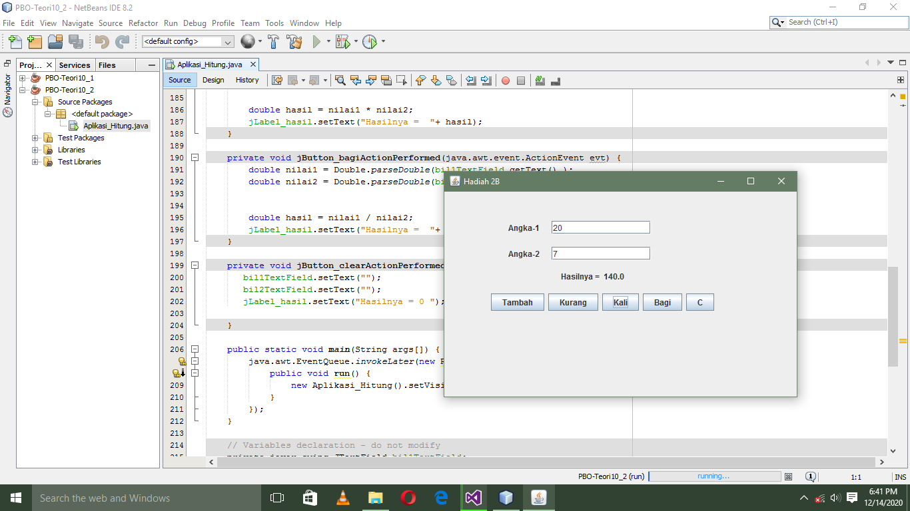

public class Aplikasi_Hitung extends javax.swing.JFrame {

public Aplikasi_Hitung() {

initComponents();

}

@SuppressWarnings("unchecked")

// <editor-fold defaultstate="collapsed" desc="Generated Code">

private void initComponents() {

jPanel1 = new javax.swing.JPanel();

jLabel1 = new javax.swing.JLabel();

jLabel2 = new javax.swing.JLabel();

bil1TextField = new javax.swing.JTextField();

bil2TextField = new javax.swing.JTextField();

jLabel_hasil = new javax.swing.JLabel();

jButton_tambah = new javax.swing.JButton();

jButton_kurang = new javax.swing.JButton();

jButton_kali = new javax.swing.JButton();

jButton_bagi = new javax.swing.JButton();

jButton_clear = new javax.swing.JButton();

setDefaultCloseOperation(javax.swing.WindowConstants.EXIT_ON_CLOSE);

setTitle("Hadiah 2B");

jLabel1.setText("Angka-1");

jLabel2.setText("Angka-2");

jLabel_hasil.setText("Hasil = 0");

jButton_tambah.setText("Tambah");

jButton_tambah.addActionListener(new java.awt.event.ActionListener() {

public void actionPerformed(java.awt.event.ActionEvent evt) {

jButton_tambahActionPerformed(evt);

}

});

jButton_kurang.setText("Kurang");

jButton_kurang.addActionListener(new java.awt.event.ActionListener() {

public void actionPerformed(java.awt.event.ActionEvent evt) {

jButton_kurangActionPerformed(evt);

}

});

jButton_kali.setText("Kali");

jButton_kali.addActionListener(new java.awt.event.ActionListener() {

public void actionPerformed(java.awt.event.ActionEvent evt) {

jButton_kaliActionPerformed(evt);

}

});

jButton_bagi.setText("Bagi");

jButton_bagi.addActionListener(new java.awt.event.ActionListener() {

public void actionPerformed(java.awt.event.ActionEvent evt) {

jButton_bagiActionPerformed(evt);

}

});

jButton_clear.setText("C");

jButton_clear.addActionListener(new java.awt.event.ActionListener() {

public void actionPerformed(java.awt.event.ActionEvent evt) {

jButton_clearActionPerformed(evt);

}

});

javax.swing.GroupLayout jPanel1Layout = new javax.swing.GroupLayout(jPanel1);

jPanel1.setLayout(jPanel1Layout);

jPanel1Layout.setHorizontalGroup(

jPanel1Layout.createParallelGroup(javax.swing.GroupLayout.Alignment.LEADING)

.addGroup(jPanel1Layout.createSequentialGroup()

.addGroup(jPanel1Layout.createParallelGroup(javax.swing.GroupLayout.Alignment.LEADING)

.addGroup(jPanel1Layout.createSequentialGroup()

.addGap(38, 38, 38)

.addGroup(jPanel1Layout.createParallelGroup(javax.swing.GroupLayout.Alignment.LEADING)

.addGroup(jPanel1Layout.createSequentialGroup()

.addComponent(jLabel2)

.addGap(18, 18, 18)

.addComponent(bil2TextField, javax.swing.GroupLayout.PREFERRED_SIZE, 149, javax.swing.GroupLayout.PREFERRED_SIZE))

.addGroup(jPanel1Layout.createSequentialGroup()

.addComponent(jLabel1)

.addGap(18, 18, 18)

.addComponent(bil1TextField, javax.swing.GroupLayout.PREFERRED_SIZE, 149, javax.swing.GroupLayout.PREFERRED_SIZE))))

.addGroup(jPanel1Layout.createSequentialGroup()

.addGap(117, 117, 117)

.addComponent(jLabel_hasil))

.addGroup(jPanel1Layout.createSequentialGroup()

.addContainerGap()

.addComponent(jButton_tambah)

.addPreferredGap(javax.swing.LayoutStyle.ComponentPlacement.RELATED)

.addComponent(jButton_kurang)

.addPreferredGap(javax.swing.LayoutStyle.ComponentPlacement.RELATED)

.addComponent(jButton_kali)

.addPreferredGap(javax.swing.LayoutStyle.ComponentPlacement.RELATED)

.addComponent(jButton_bagi)

.addPreferredGap(javax.swing.LayoutStyle.ComponentPlacement.RELATED)

.addComponent(jButton_clear)))

.addContainerGap(68, Short.MAX_VALUE))

);

jPanel1Layout.setVerticalGroup(

jPanel1Layout.createParallelGroup(javax.swing.GroupLayout.Alignment.LEADING)

.addGroup(jPanel1Layout.createSequentialGroup()

.addGap(25, 25, 25)

.addGroup(jPanel1Layout.createParallelGroup(javax.swing.GroupLayout.Alignment.BASELINE)

.addComponent(jLabel1)

.addComponent(bil1TextField, javax.swing.GroupLayout.PREFERRED_SIZE, javax.swing.GroupLayout.DEFAULT_SIZE, javax.swing.GroupLayout.PREFERRED_SIZE))

.addGap(19, 19, 19)

.addGroup(jPanel1Layout.createParallelGroup(javax.swing.GroupLayout.Alignment.BASELINE)

.addComponent(jLabel2)

.addComponent(bil2TextField, javax.swing.GroupLayout.PREFERRED_SIZE, javax.swing.GroupLayout.DEFAULT_SIZE, javax.swing.GroupLayout.PREFERRED_SIZE))

.addGap(16, 16, 16)

.addComponent(jLabel_hasil)

.addGap(18, 18, 18)

.addGroup(jPanel1Layout.createParallelGroup(javax.swing.GroupLayout.Alignment.BASELINE)

.addComponent(jButton_tambah)

.addComponent(jButton_kurang)

.addComponent(jButton_kali)

.addComponent(jButton_bagi)

.addComponent(jButton_clear))

.addContainerGap(94, Short.MAX_VALUE))

);

javax.swing.GroupLayout layout = new javax.swing.GroupLayout(getContentPane());

getContentPane().setLayout(layout);

layout.setHorizontalGroup(

layout.createParallelGroup(javax.swing.GroupLayout.Alignment.LEADING)

.addGroup(layout.createSequentialGroup()

.addContainerGap()

.addComponent(jPanel1, javax.swing.GroupLayout.PREFERRED_SIZE, javax.swing.GroupLayout.DEFAULT_SIZE, javax.swing.GroupLayout.PREFERRED_SIZE)

.addContainerGap(102, Short.MAX_VALUE))

);

layout.setVerticalGroup(

layout.createParallelGroup(javax.swing.GroupLayout.Alignment.LEADING)

.addGroup(layout.createSequentialGroup()

.addContainerGap()

.addComponent(jPanel1, javax.swing.GroupLayout.PREFERRED_SIZE, javax.swing.GroupLayout.DEFAULT_SIZE, javax.swing.GroupLayout.PREFERRED_SIZE)

.addContainerGap(42, Short.MAX_VALUE))

);

pack();

}// </editor-fold>

private void jButton_tambahActionPerformed(java.awt.event.ActionEvent evt) {

double nilai1 = Double.parseDouble(bil1TextField.getText() );

double nilai2 = Double.parseDouble(bil2TextField.getText() );

double hasil = nilai1 + nilai2;

jLabel_hasil.setText("Hasilnya = "+ hasil);

}

private void jButton_kurangActionPerformed(java.awt.event.ActionEvent evt) {

double nilai1 = Double.parseDouble(bil1TextField.getText() );

double nilai2 = Double.parseDouble(bil2TextField.getText() );

double hasil = nilai1 - nilai2;

jLabel_hasil.setText("Hasilnya = "+ hasil);

}

private void jButton_kaliActionPerformed(java.awt.event.ActionEvent evt) {

double nilai1 = Double.parseDouble(bil1TextField.getText() );

double nilai2 = Double.parseDouble(bil2TextField.getText() );

double hasil = nilai1 * nilai2;

jLabel_hasil.setText("Hasilnya = "+ hasil);

}

private void jButton_bagiActionPerformed(java.awt.event.ActionEvent evt) {

double nilai1 = Double.parseDouble(bil1TextField.getText() );

double nilai2 = Double.parseDouble(bil2TextField.getText() );

double hasil = nilai1 / nilai2;

jLabel_hasil.setText("Hasilnya = "+ hasil);

}

private void jButton_clearActionPerformed(java.awt.event.ActionEvent evt) {

bil1TextField.setText("");

bil2TextField.setText("");

jLabel_hasil.setText("Hasilnya = 0 ");

}

public static void main(String args[]) {

java.awt.EventQueue.invokeLater(new Runnable() {

public void run() {

new Aplikasi_Hitung().setVisible(true);

}

});

}

// Variables declaration - do not modify

private javax.swing.JTextField bil1TextField;

private javax.swing.JTextField bil2TextField;

private javax.swing.JButton jButton_bagi;

private javax.swing.JButton jButton_clear;

private javax.swing.JButton jButton_kali;

private javax.swing.JButton jButton_kurang;

private javax.swing.JButton jButton_tambah;

private javax.swing.JLabel jLabel1;

private javax.swing.JLabel jLabel2;

private javax.swing.JLabel jLabel_hasil;

private javax.swing.JPanel jPanel1;

// End of variables declaration

}